DATABASE SYSTEMS LAB PROJECT
SECTION: V20

MEMBERS:

ZAINAB IMRAN f2024266205
MOMINA FAROOQ f20242661179
MAIRA WAHEED f20242661184

- Introduction:
This pharmacy database system has been designed to keep employee , customer and medicine track in order to stock inventory in discard expired medicine. History of this pharmacy is being recorded in order to keep an organized running of the system.

- Logical Database Design:

Pharmacy Management Systems

Customer:
gender
phone no
name
dob
ssn (primary key)
address
relation: pays with entity Bill
relation: holds with entity prescription

Bill:
ssn primary key
orderID foriegn key
customerPay derived attribute
total amount derived attribute
realtion: makes with entity: Order

Prescription:
prescID primary key
ssn
decID
PrescrDate
realtion: uses with entity Order

Order:
orderID primary key
prescID
EmpID
Orderdate
relation: contains with entity Ordered Drugs
realtion: prepares with entity Employee

Ordered Drugs:
Price
OrderID primary key
DrugName foreign key

- Entity-Relationship Diagram

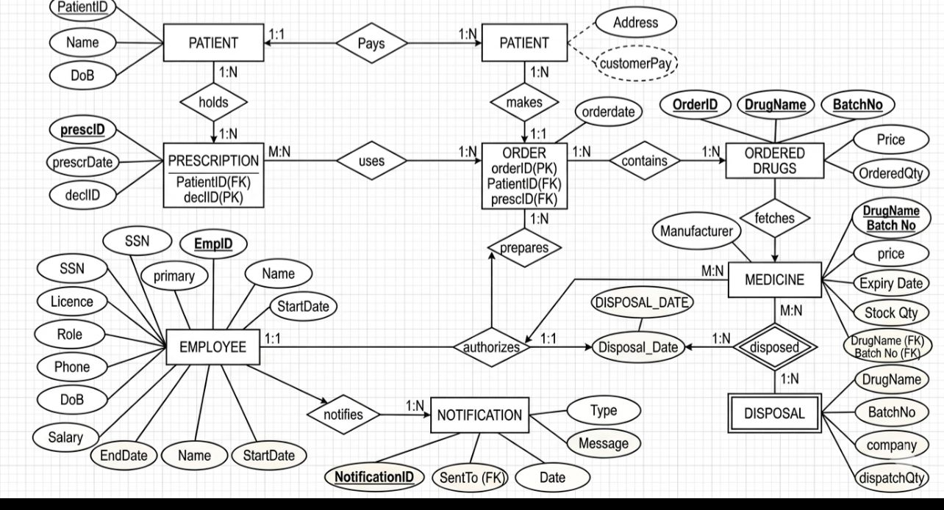

- Relational Data Model

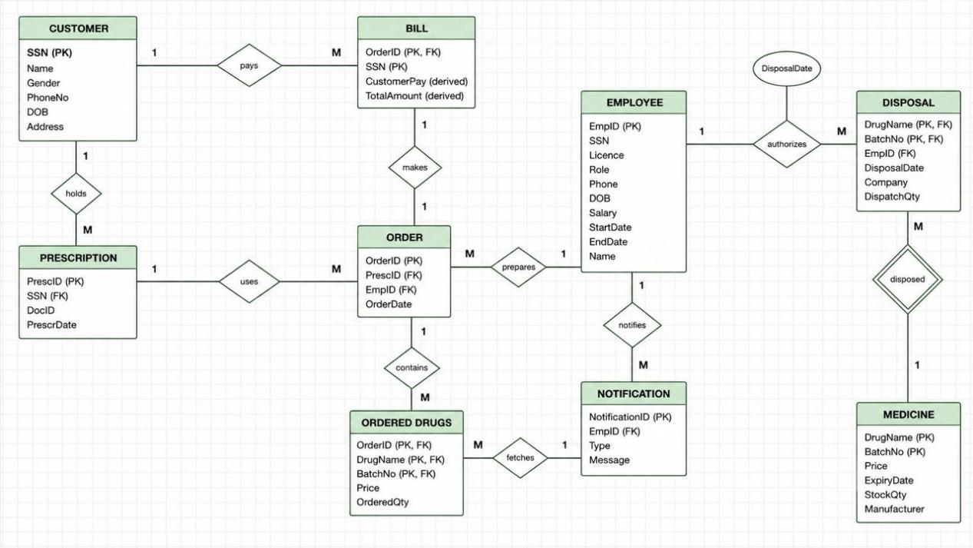
- Enhanced-Entity Relationship Model

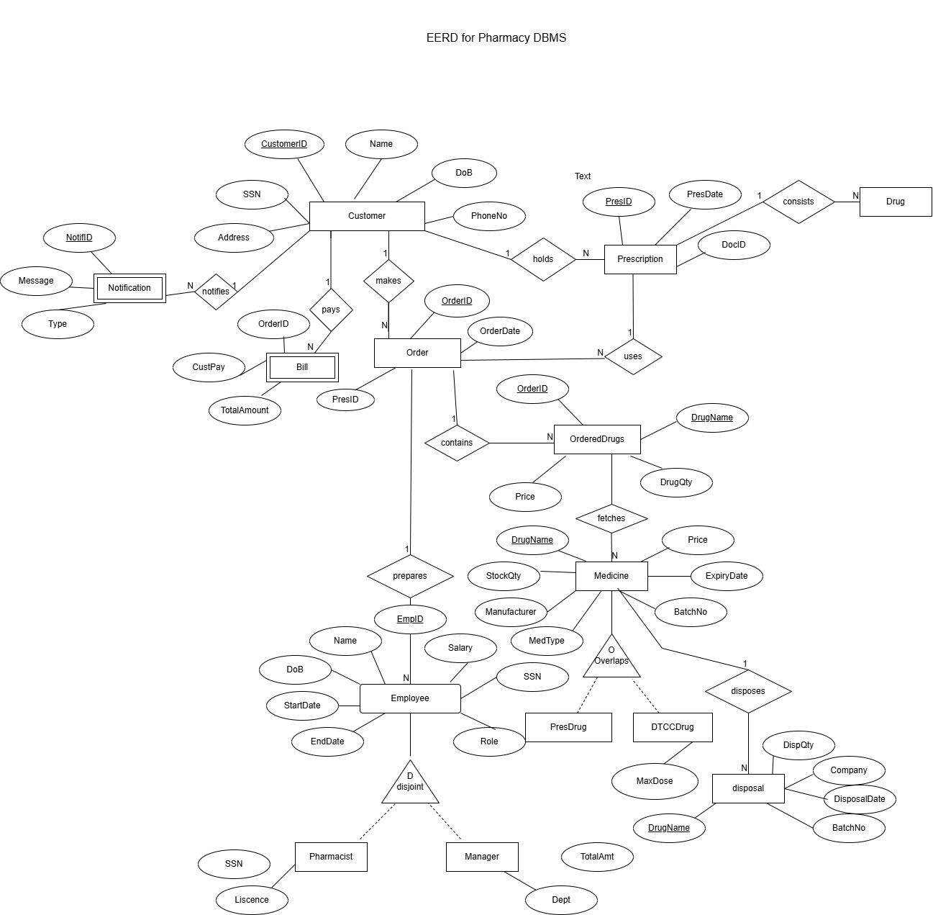

- SQL Queries working

Section | Content | Details
1 | CREATE TABLE | 16 tables with all FK, CHECK, UNIQUE, NOT NULL constraints
2 | INSERT DATA | 120 patients, 35 staff, 15 doctors, 12 nurses, 120 appointments, 100 medical records, 110 bills, 100+ more
3 | ALTER queries | ADD COLUMN, MODIFY, RENAME COLUMN, ADD CONSTRAINT, ADD INDEX
4 | SELECT queries | WHERE, AND/OR, LIKE, BETWEEN, IN, IS NULL, ORDER BY, LIMIT, DISTINCT, GROUP BY, HAVING, SUM/AVG/MIN/MAX, CASE WHEN, Subqueries, EXISTS, DATE functions, String functions
5 | All JOIN types | INNER, LEFT, RIGHT, CROSS, SELF JOIN
6 | VIEWS | 5 views: prescriptions, outstanding bills, doctor schedule, inpatients, revenue
7 | INDEXES | 10 indexes including FULLTEXT on Prescription & Diagnosis
8 | STORED PROCEDURES | 6 procedures: get prescriptions, book appointment, generate bill, discharge patient, monthly revenue, search by drug
9 | TRIGGERS | 6 triggers: auto-billing, room availability, slot validation, prescription audit, negative amount prevention
10 | Referential Integrity | Demonstrations of CASCADE, SET NULL, RESTRICT behaviors
11 | Pharmacy queries | Monthly prescriptions, drug frequency, unpaid bills, revenue analysis

